**Neural Networks and Deep Learning**

**Assignment 2**

**RISHITHA REDDY LIKKI**

**700748512**

**Use Case Description: Predicting the diabetes disease Programming elements:**

**Keras Basics In class programming:**

1. **Use the use case in the class:**
2. **Add more Dense layers to the existing code and check how the accuracy changes.**

Here imported necessary libraries and added more dense layers and found the accuracy.

Here are the screenshots below of the executed result.

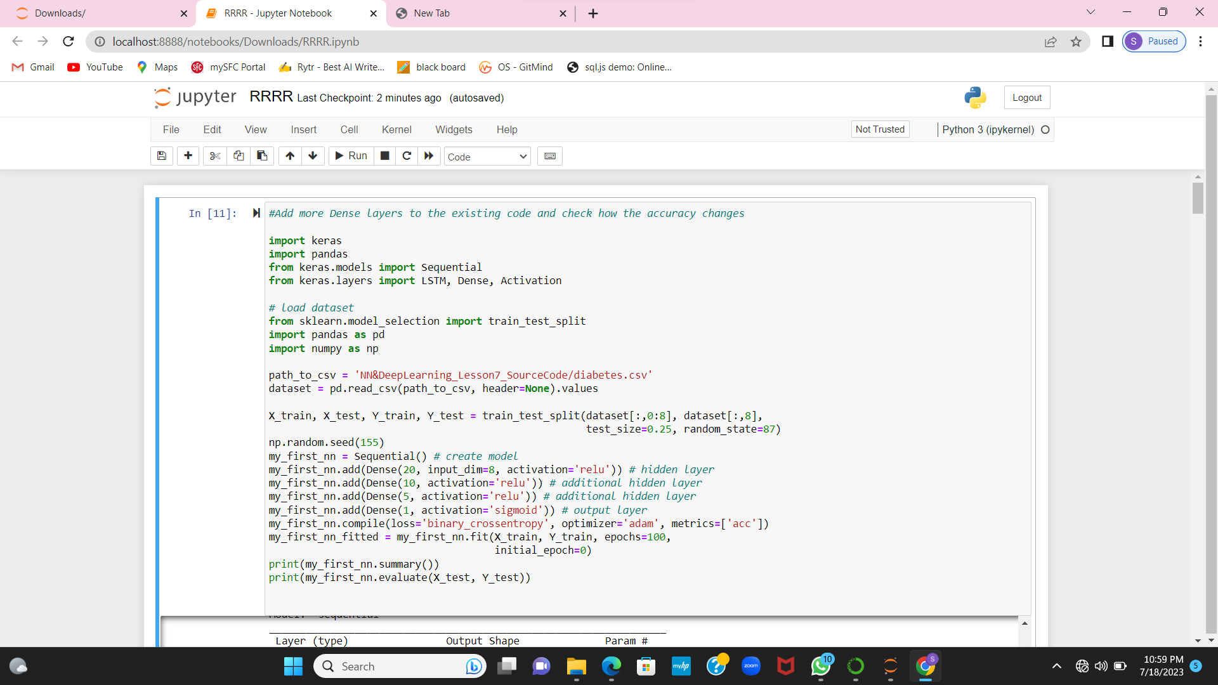

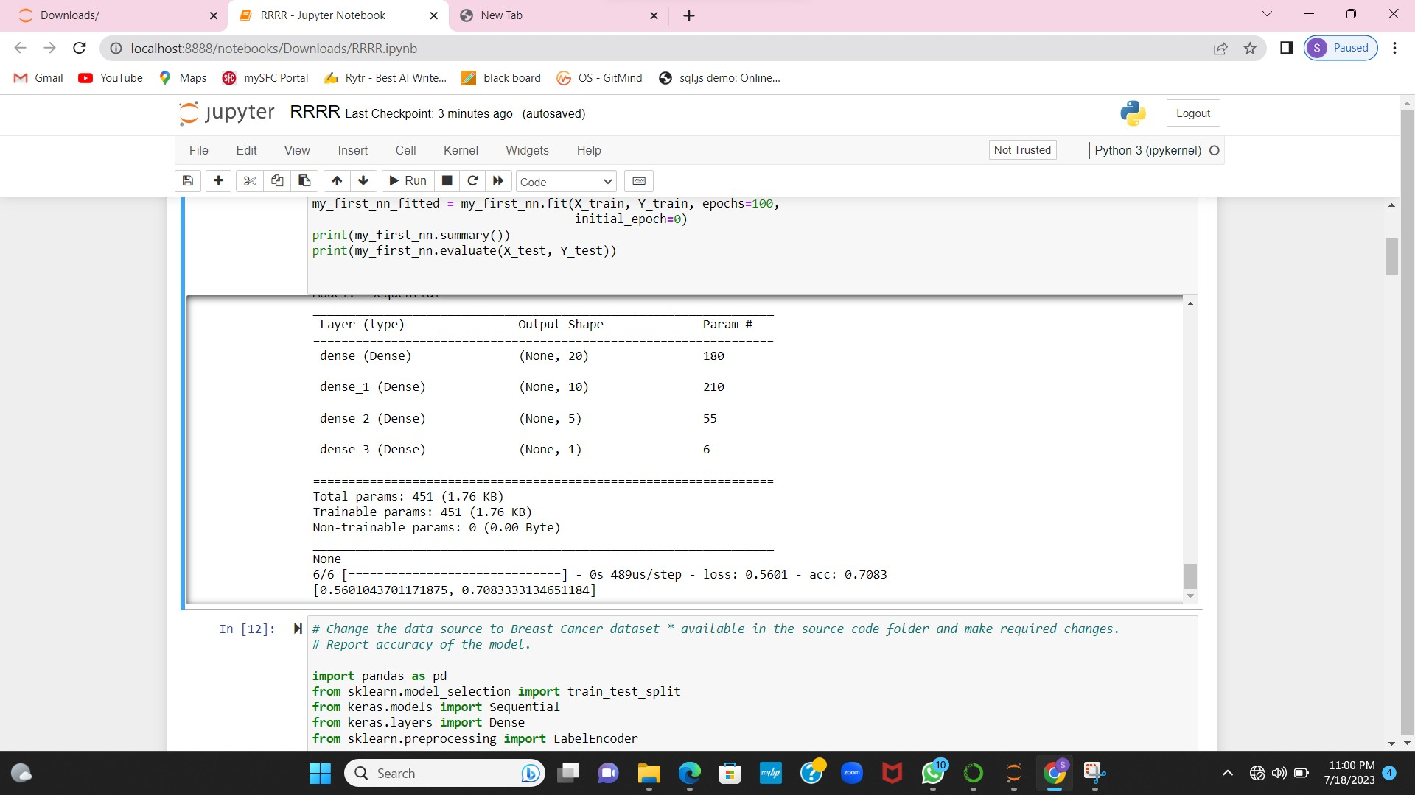

1. **Change the data source to Breast Cancer dataset * available in the source code folder and make required changes. Report accuracy of the model.**

Here just changed the dataset to Bread cancer dataset and made required changes. And found the accuracy model.

Used sequential model to train the data.

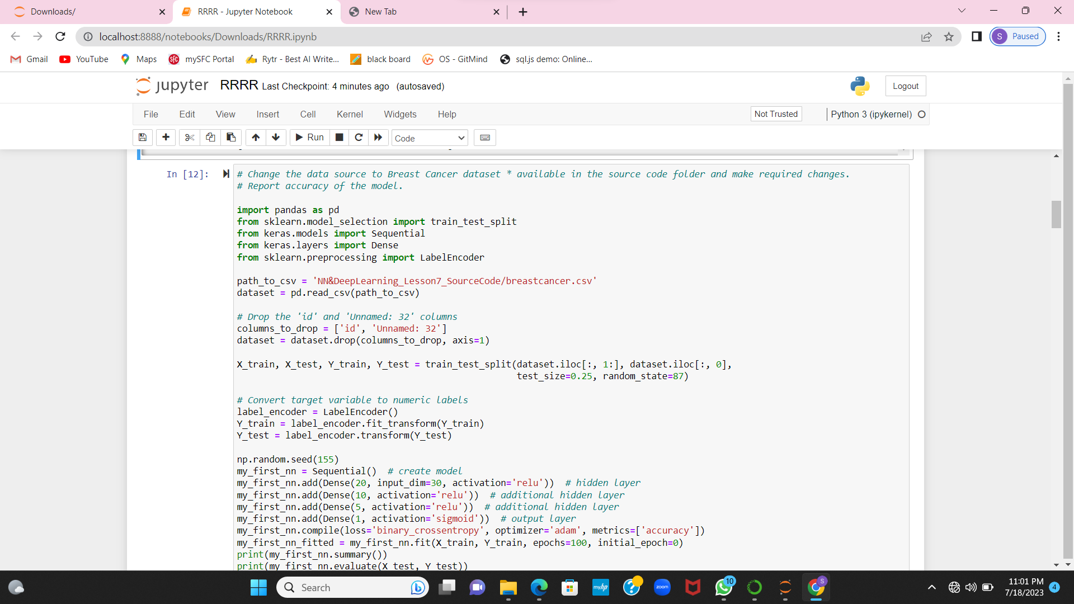

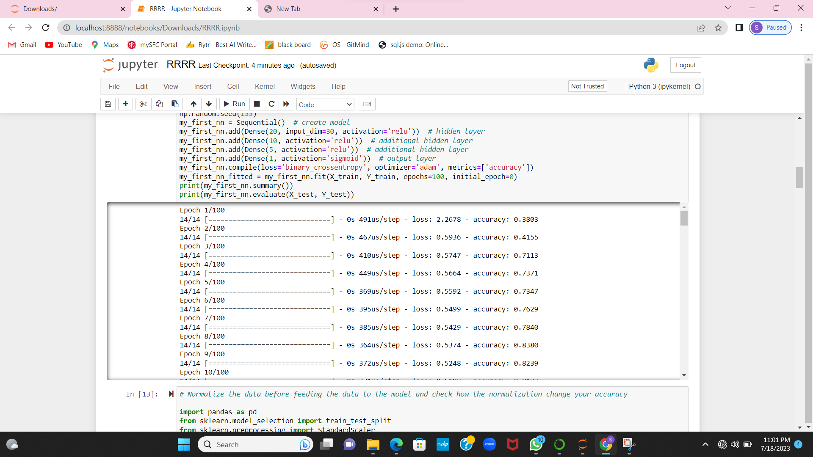

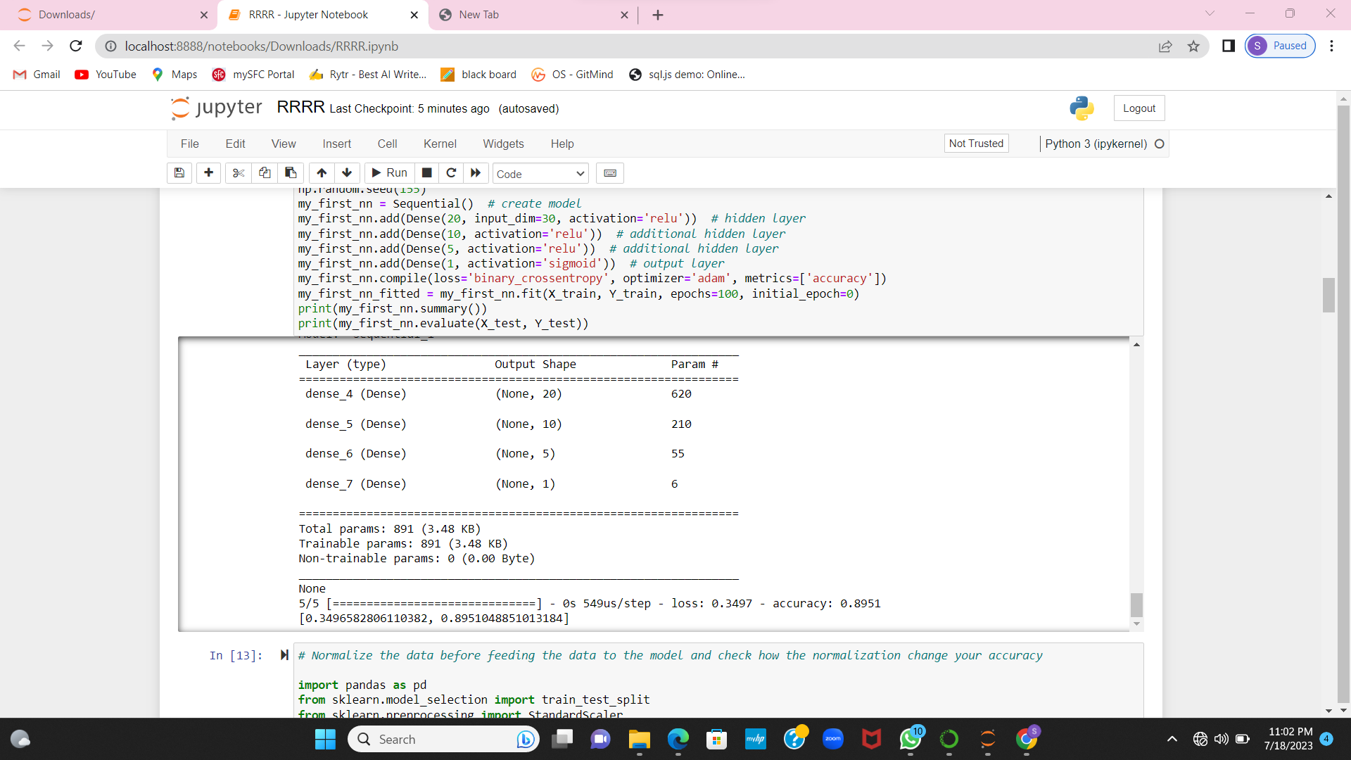

1. **Normalize the data before feeding the data to the model and check how the normalization change your accuracy (code given below). from sklearn.preprocessing import StandardScaler sc = StandardScaler()**

Using the standard scaler, checked the normalization change .

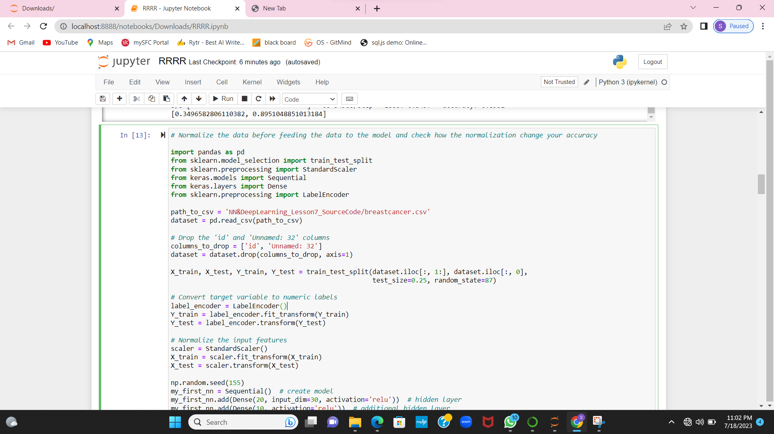

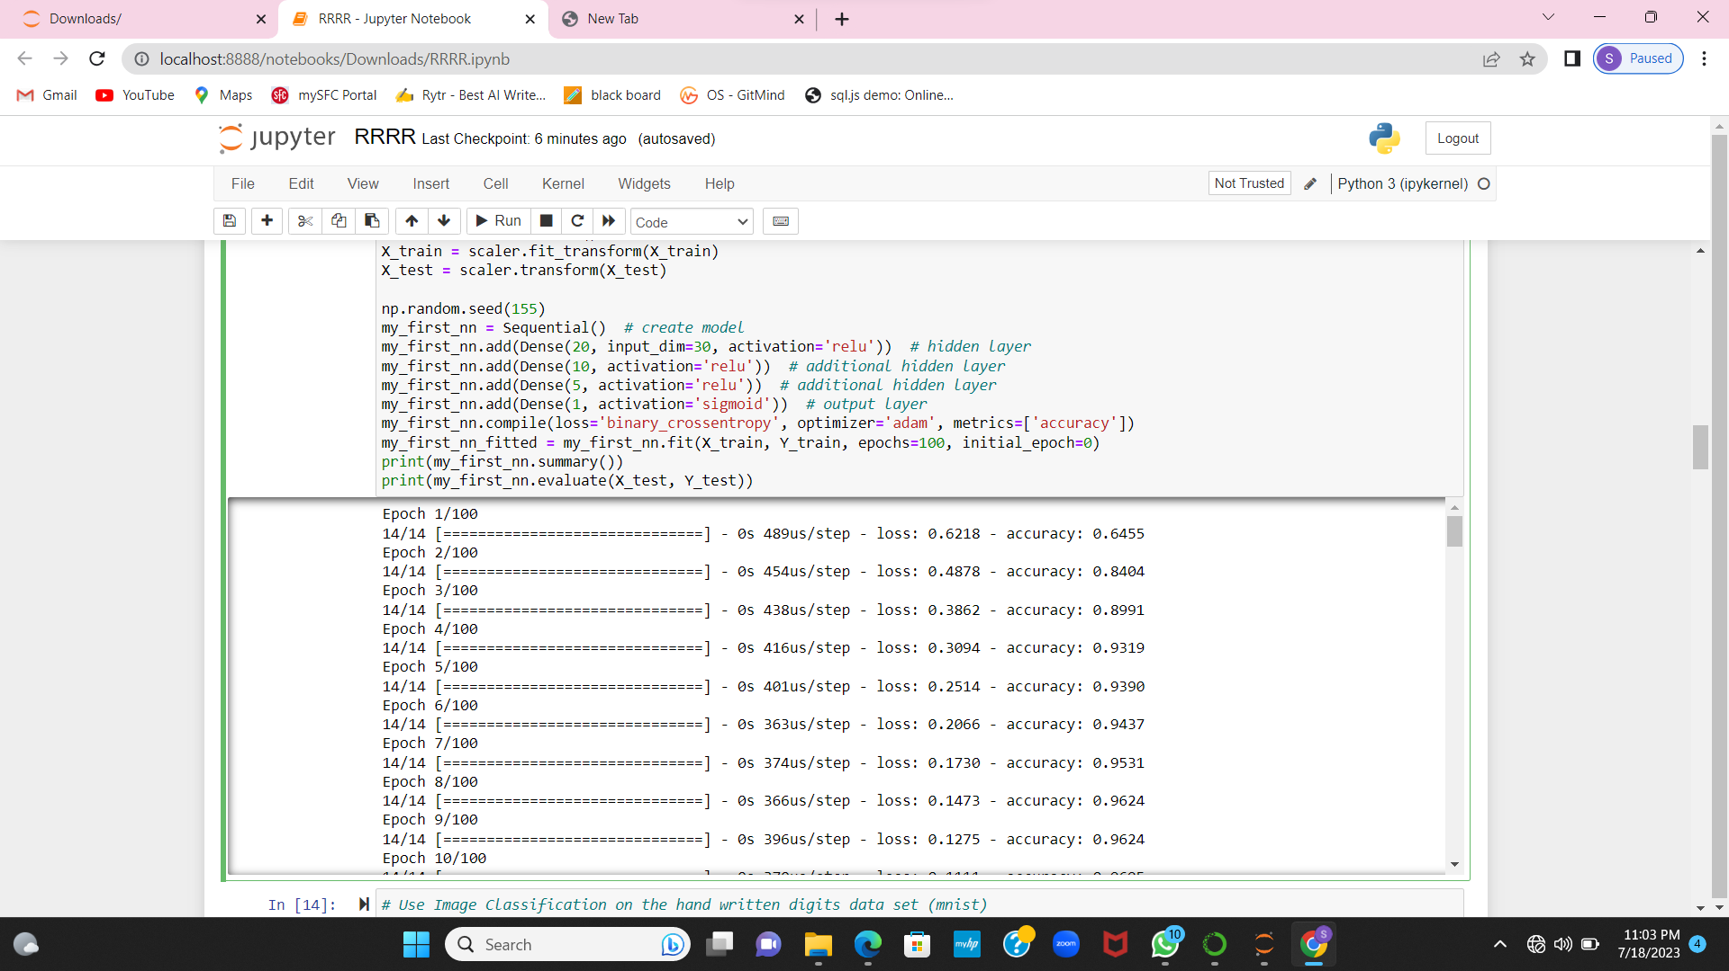

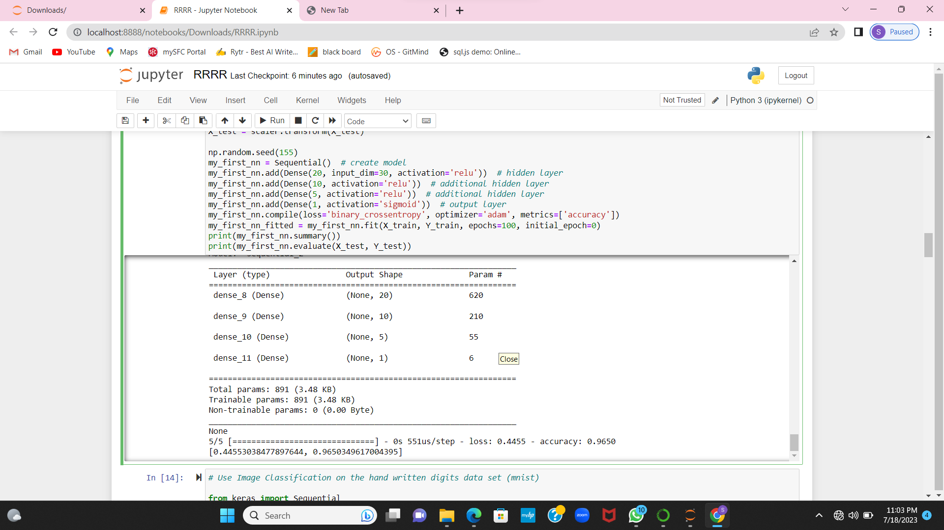

**Use Image Classification on the hand written digits data set (mnist)**

1. **Plot the loss and accuracy for both training data and validation data using the history object in the source code.**

Used image classification on the hand written data.

Imported necessary libraries and plotted data for both training data and validation data using the source code.

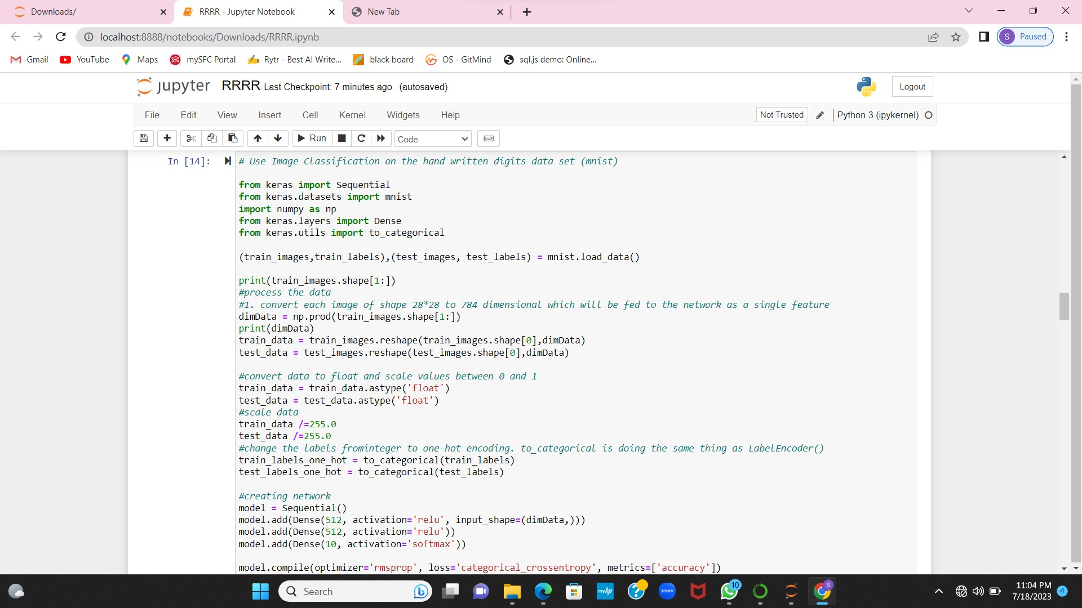

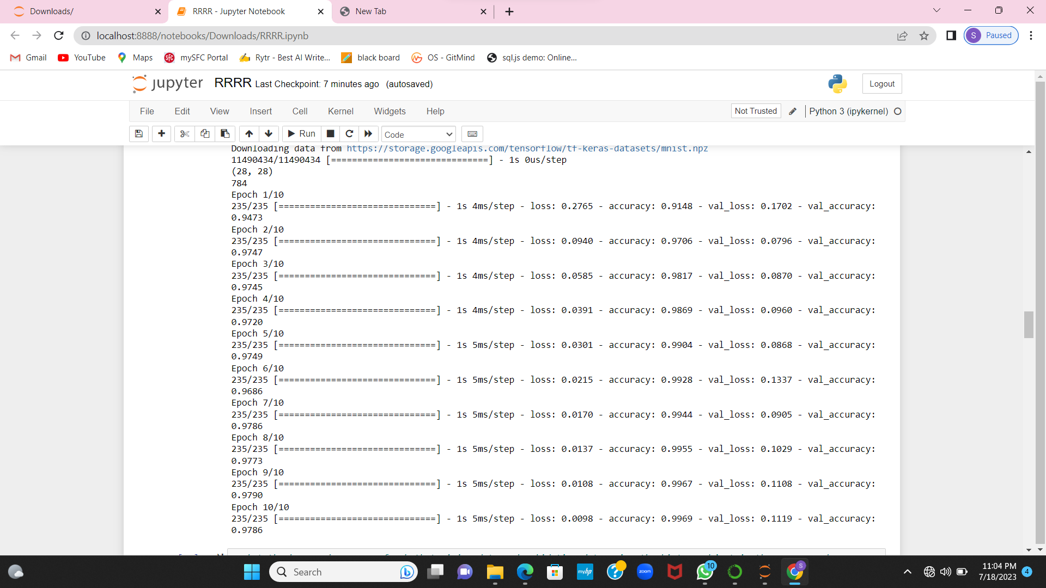

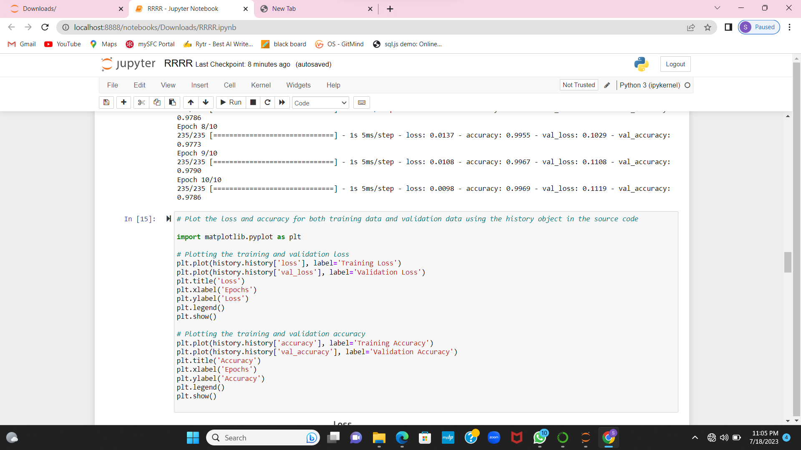

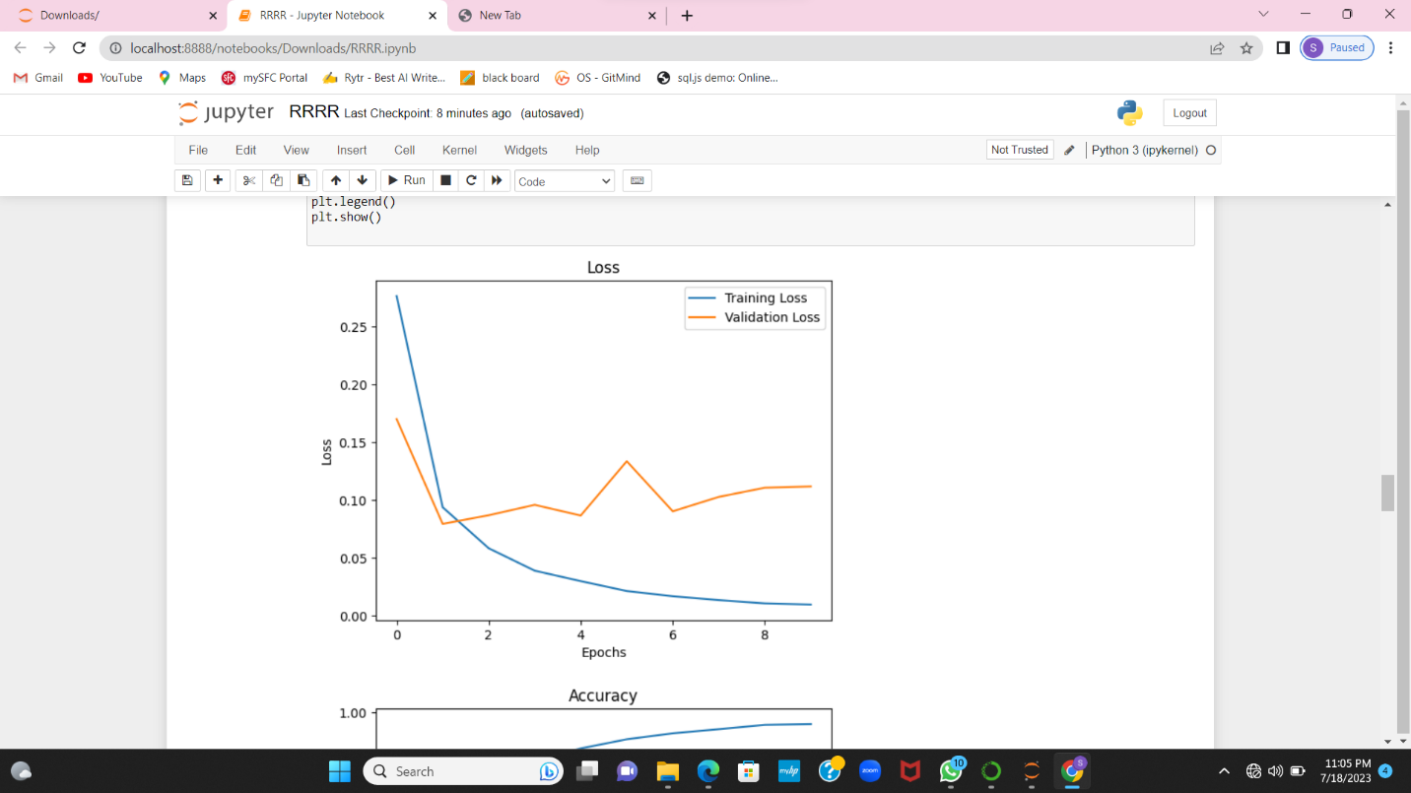

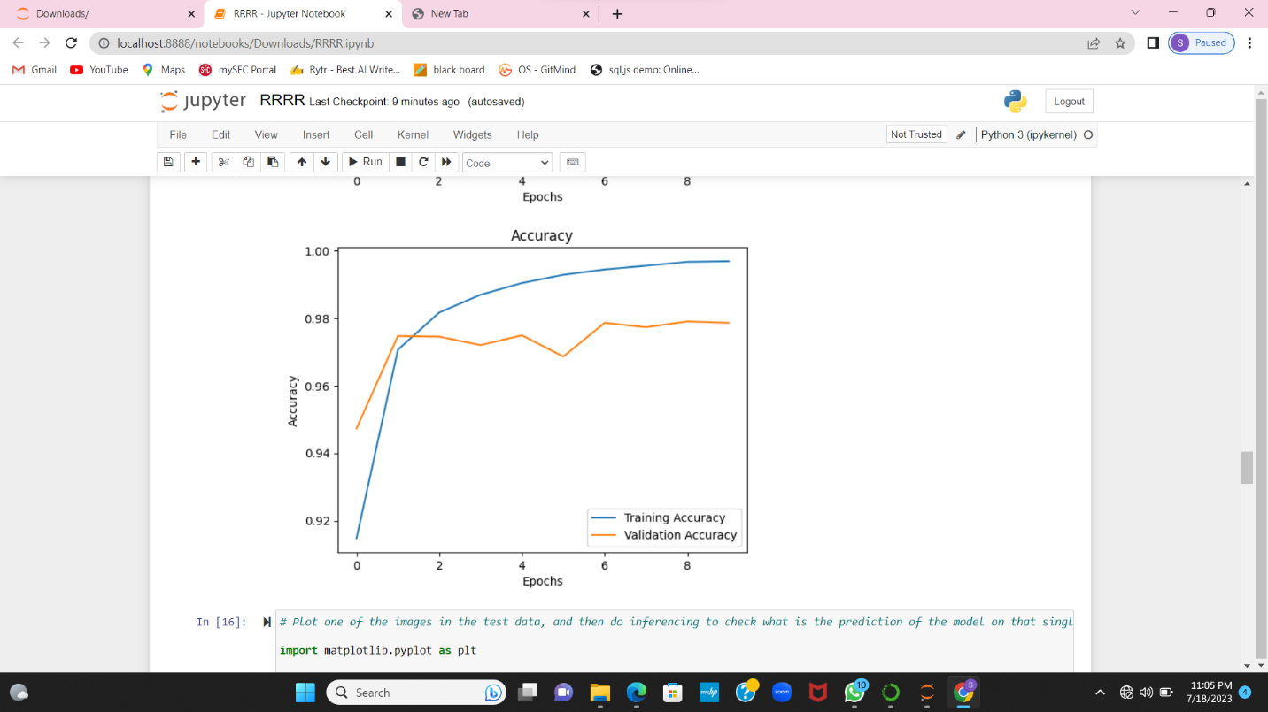

**B Plot one of the images in the test data, and then do inferencing to check what is the prediction of the model on that single image.**

Plotted one of the image in test data and predicted model on that image.

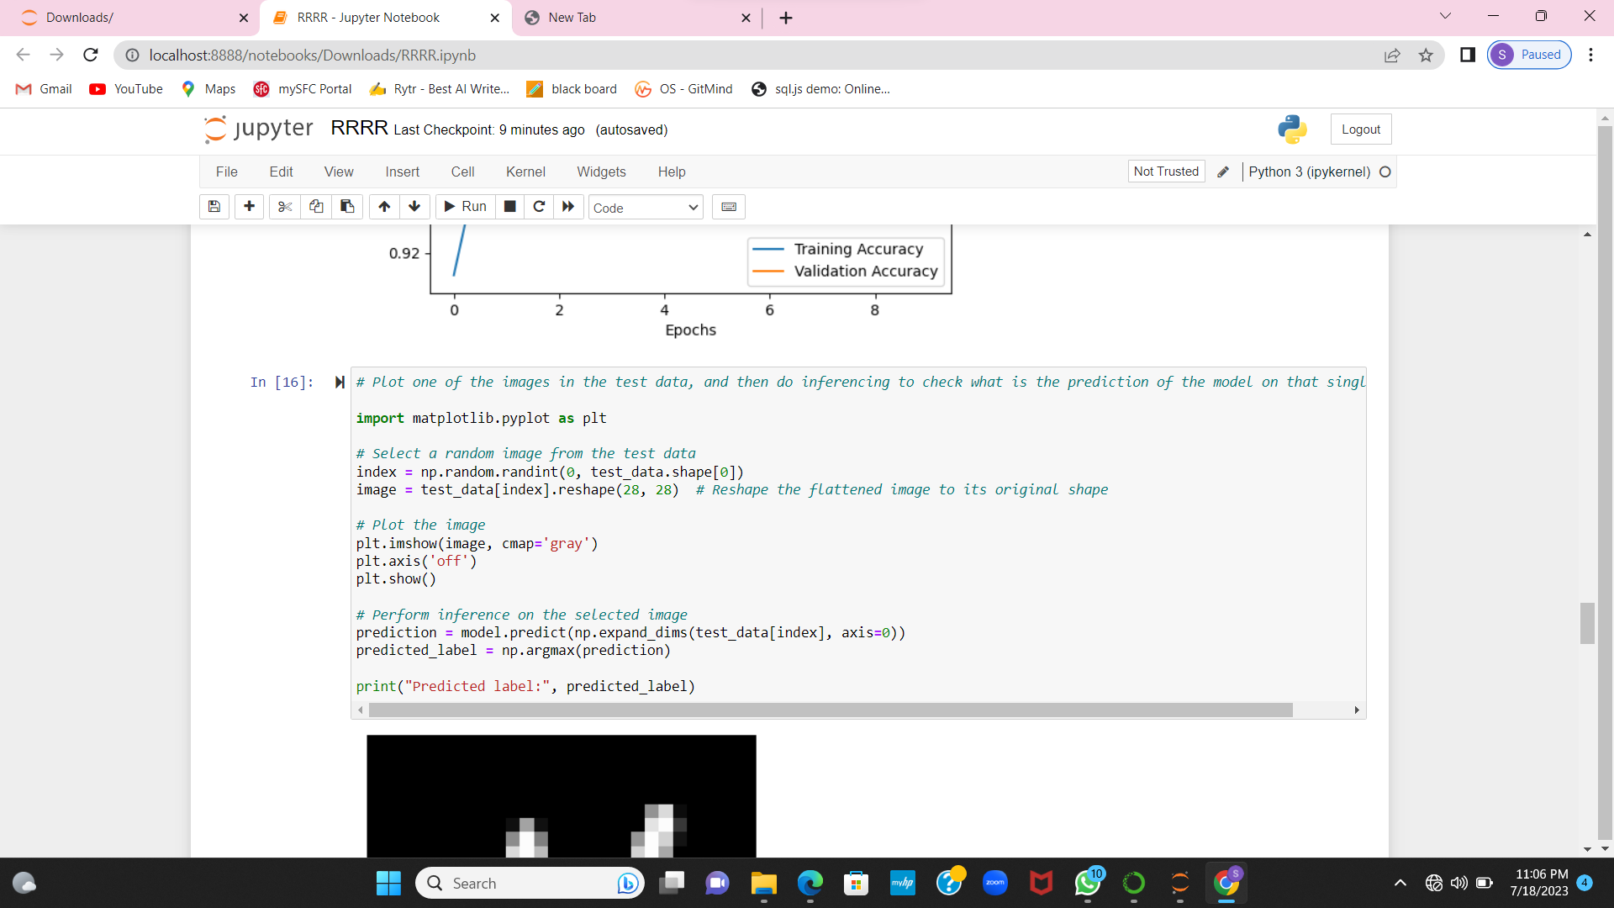

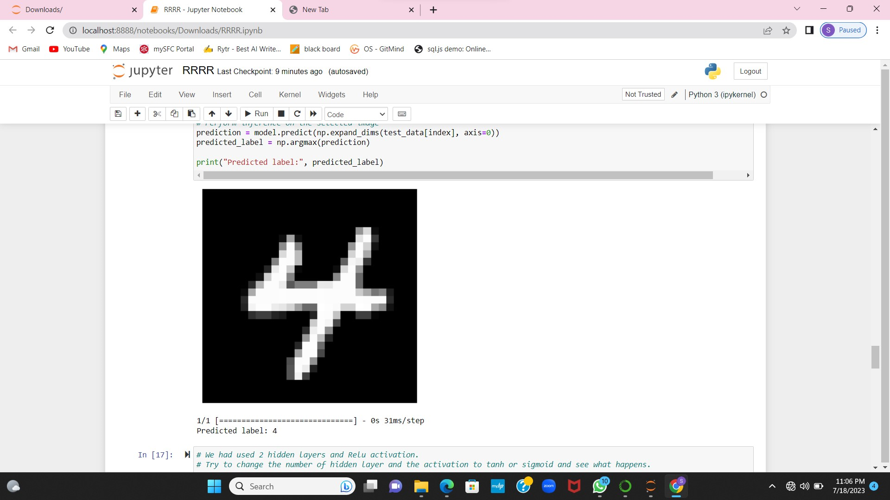

**3 We had used 2 hidden layers and Relu activation. Try to change the number of hidden layer and the activation to tanh or sigmoid and see what happens**.

Changed the number of hidden layer and activation to tanh

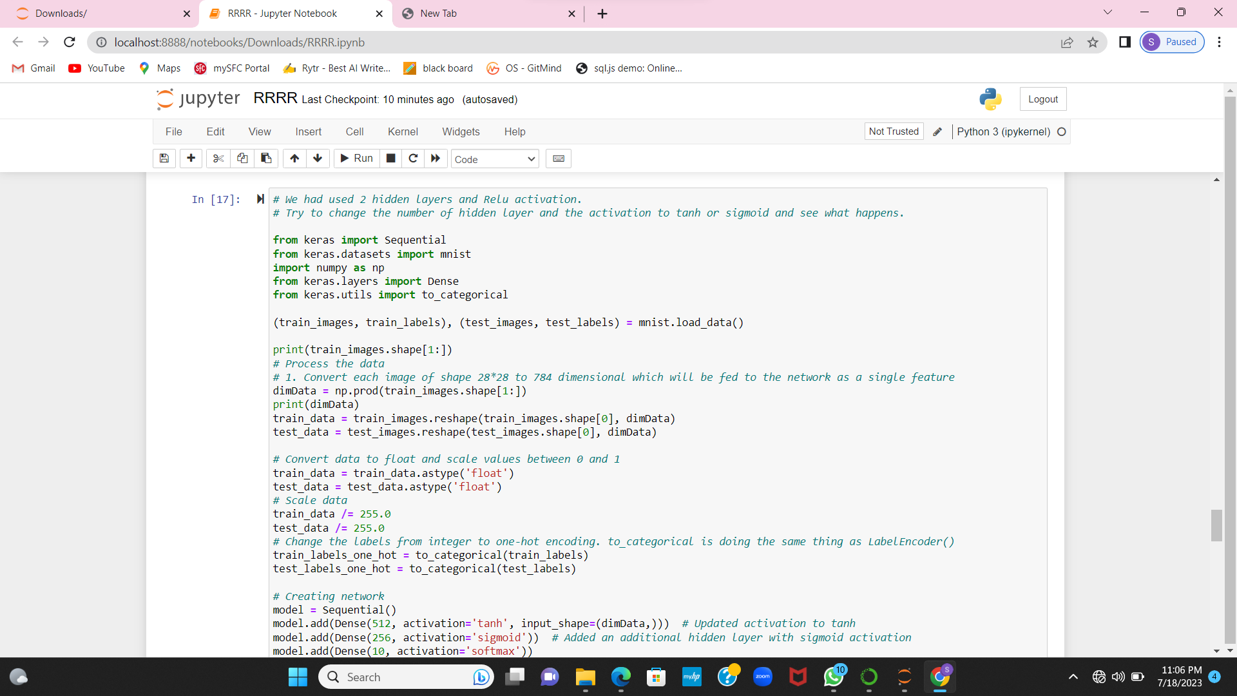

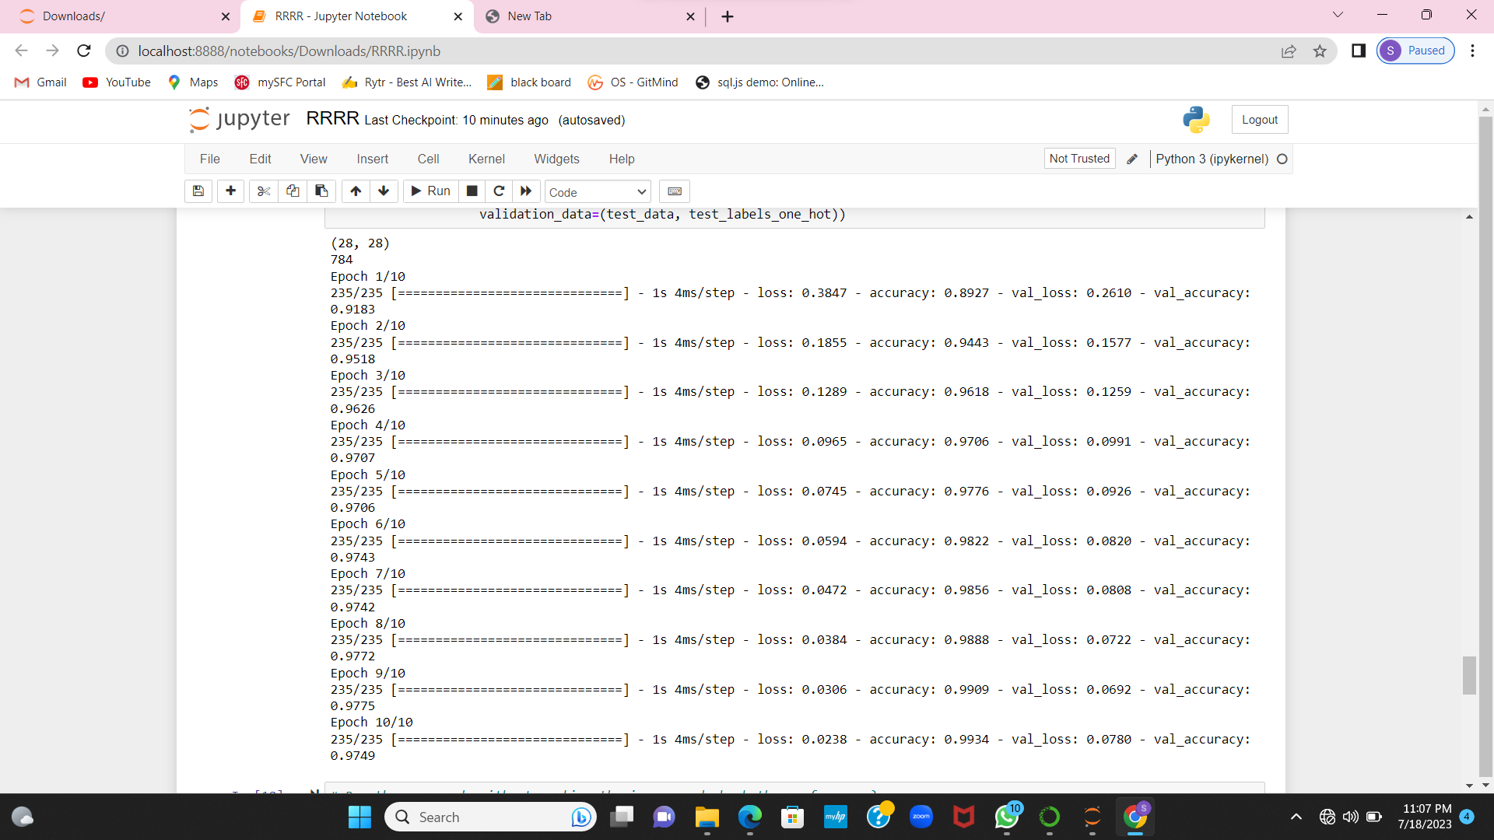

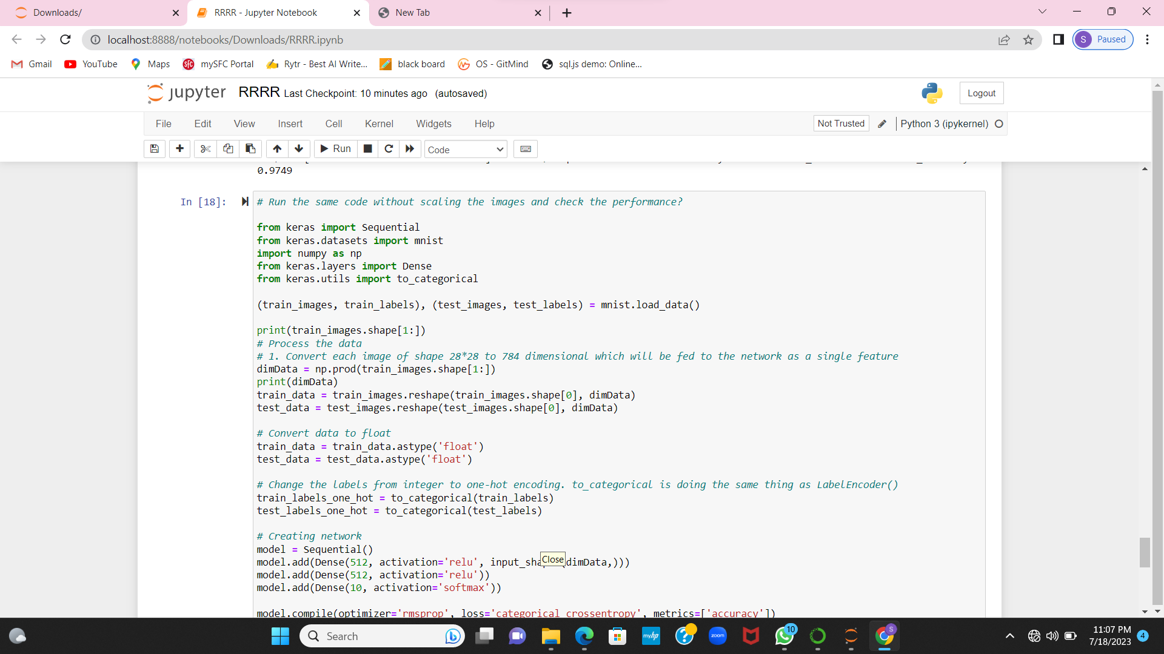

1. **Run the same code without scaling the images and check the performance?**

Executed the same code without scaling images and checked performance. Here are the results of it.





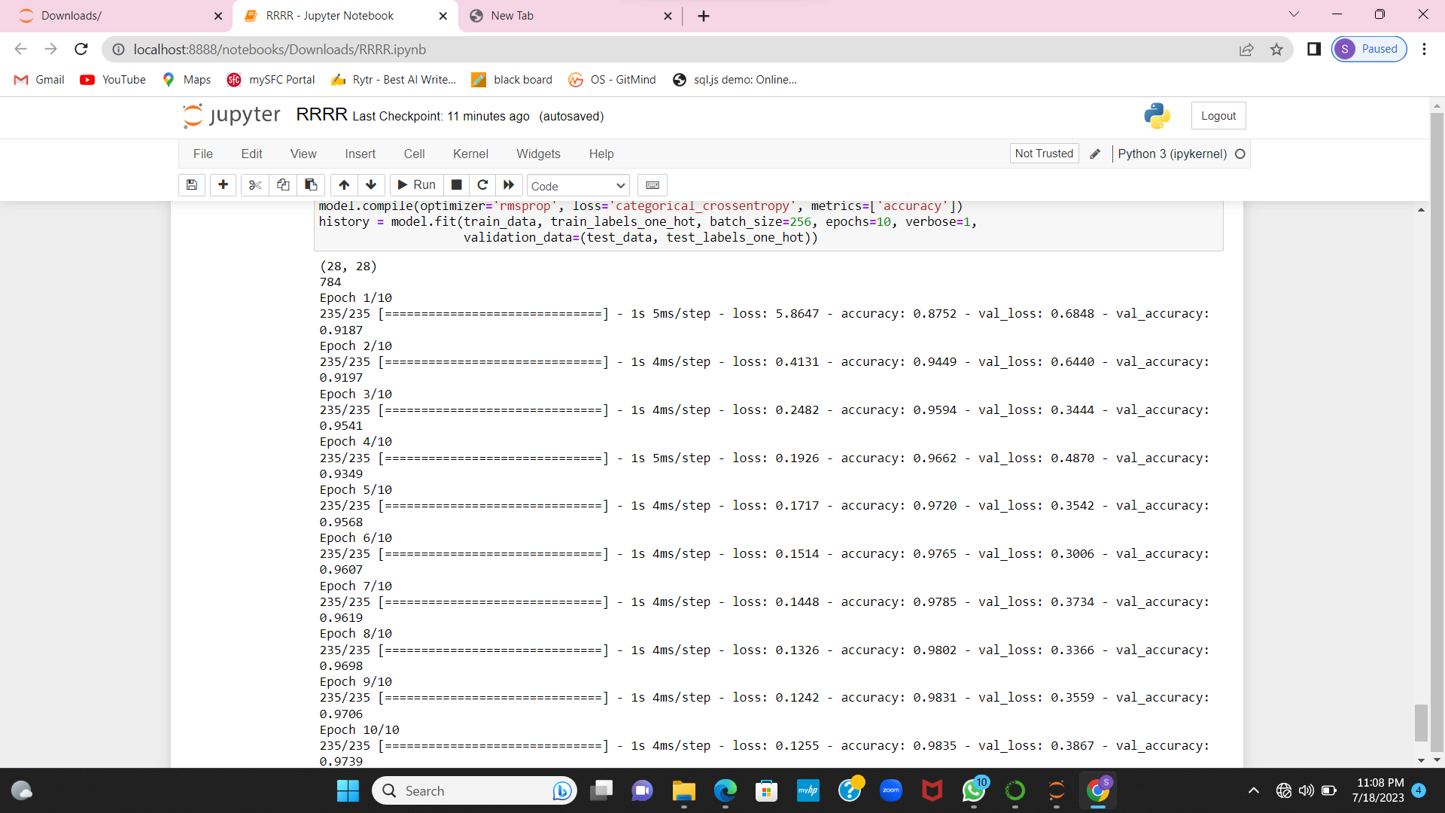

**Github link**

**https://github.com/rishithalikki/rishitha_assign2**

**Videolink**

[**https://github.com/rishithalikki/rishitha_assign2**](https://github.com/rishithalikki/rishitha_assign2)